Code

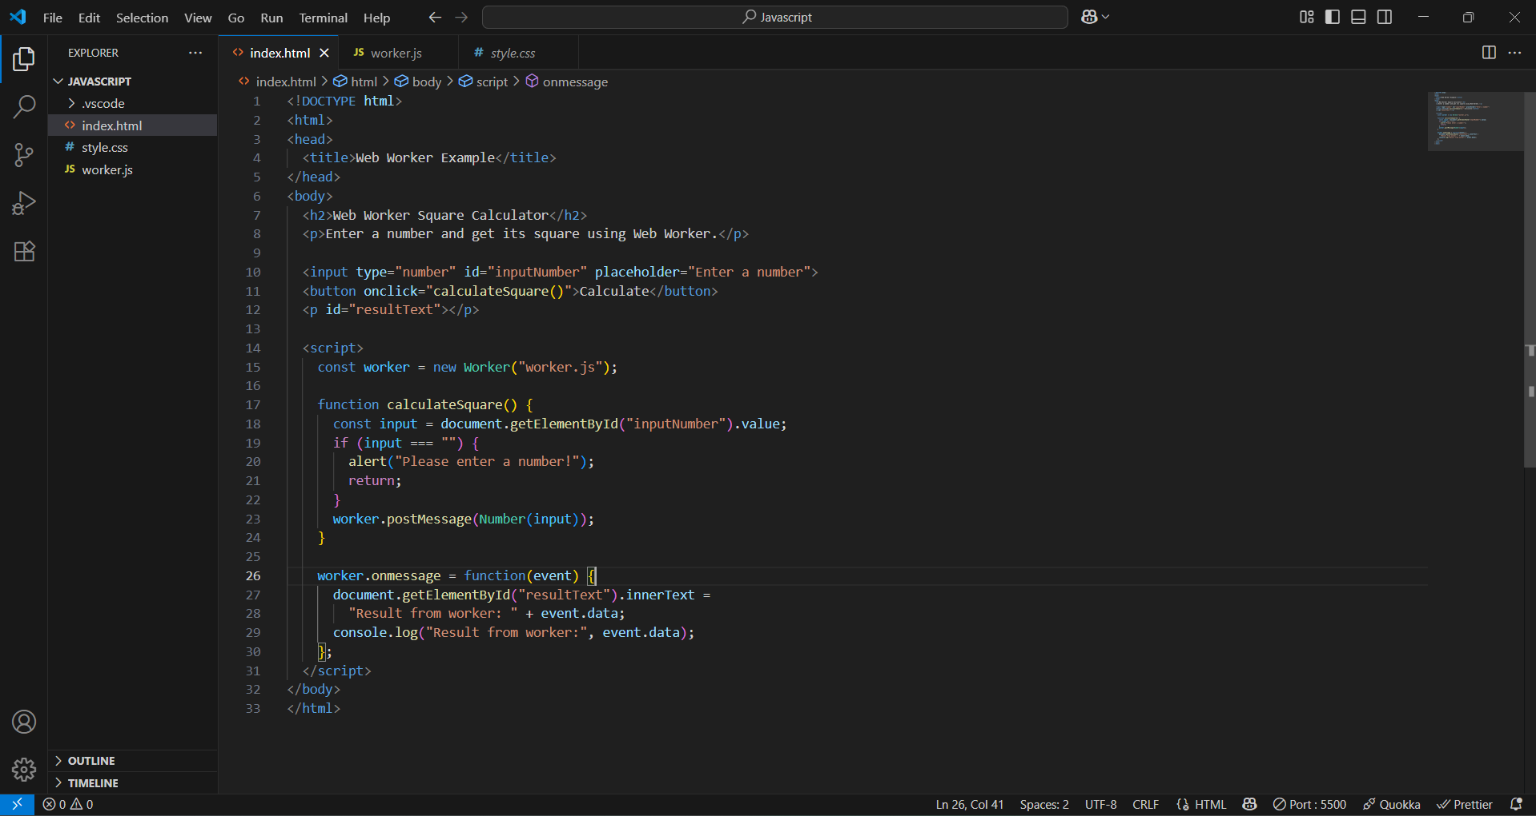

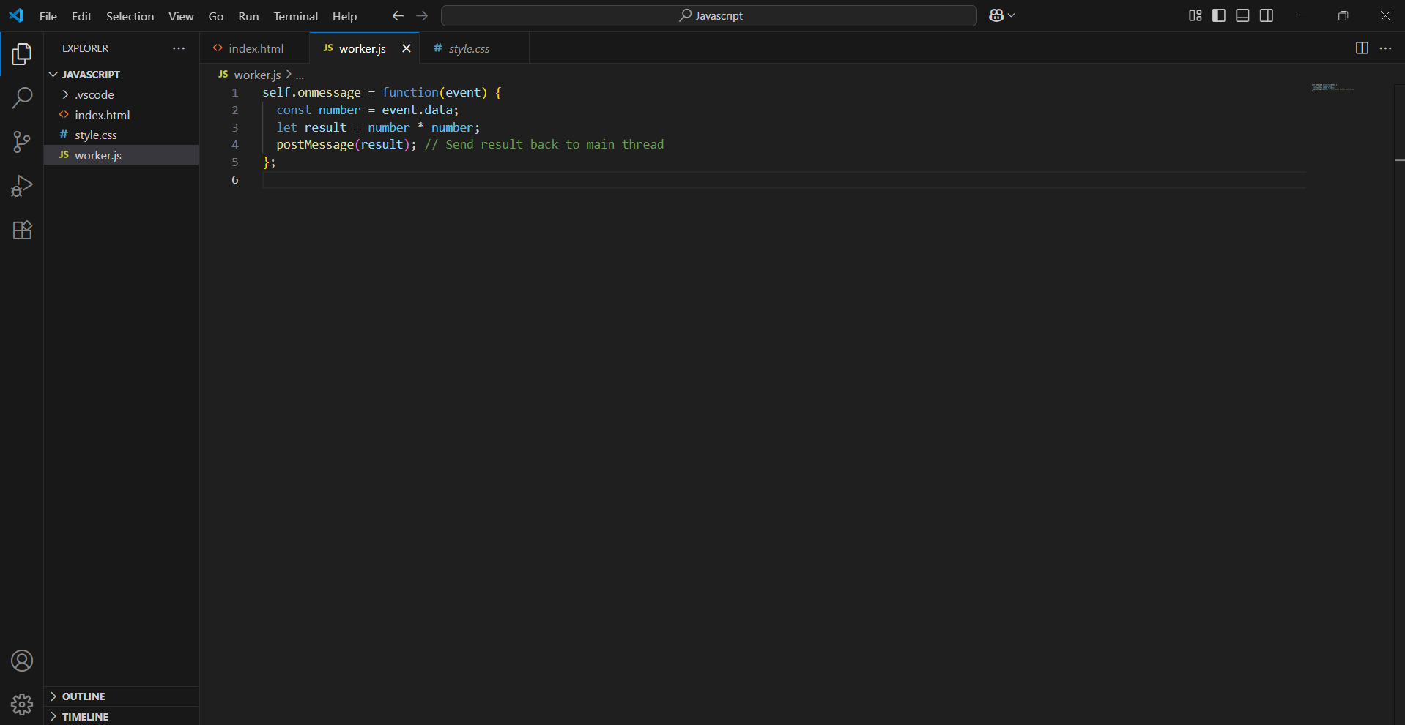

Index.html

1. The index.html file creates a simple web page with an input box for entering a number, a button to trigger the calculation, and a paragraph to display the result.
2. When the button is clicked, it runs the calculateSquare() function defined in the script.
3. Inside this function, the value entered by the user is read from the input field.
4. The value is sent to a Web Worker using the postMessage() method.
5. A Web Worker is created using new Worker("worker.js"), which loads the worker.js file and runs it in the background.
6. In worker.js, the worker waits for data using self.onmessage, receives the number, and calculates its square.
7. After calculating, the worker sends the result back to the main page using postMessage().
8. Back in the main HTML file, the script listens for the response using worker.onmessage.
9. When the result is received, it is displayed on the web page in a paragraph and also logged to the browser console.
10. This process allows the calculation to happen in the background without freezing or slowing down the main webpage

Worker.js

1. The worker.js file is a separate JavaScript file that runs in the background as a Web Worker.
2. It listens for messages from the main HTML page using self.onmessage.
3. When a message is received, it extracts the data (which is the number sent from the main thread).
4. It calculates the square of the received number using number \* number.
5. After calculating the result, it sends the result back to the main thread using postMessage().
6. This allows the main page to receive and display the result without handling the calculation directly.
7. Running this code in a worker helps keep the main webpage responsive, especially when dealing with heavier calculations.

Output

